Navigational Flow
- When the player selects the “TiniWings” icon, the app must display the splash screen for three seconds. This is the splash screen:
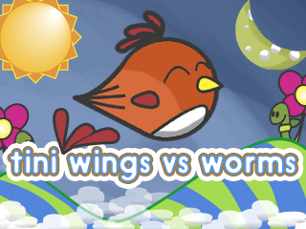
Then after the splash screen displays for 3 seconds, the menu options must be displayed similar to the J2ME:
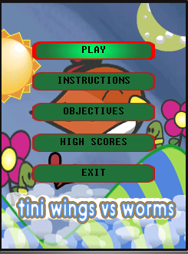
Play Command:
The play command must have a Pause and Restart command.
For the Android version, an additional menu option must be added to allow the user to turn on & off the game audio sounds. The other additional option is to allow the player to control the audio volume.
This is how the Instructions, High Scores and Objectives screen looks like:
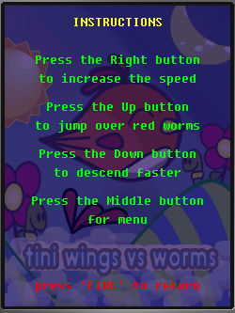
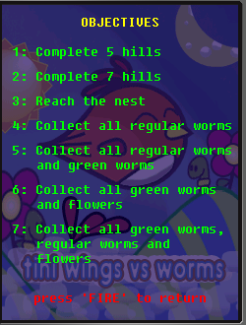
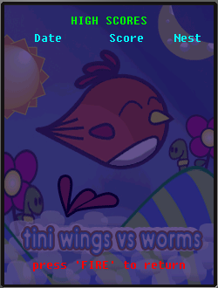

Note that I have attach in the email for the background sound files.
The compile error you are experience could be due to the changes from “Tiny” to “Tini”. The changes must be made manually on the project itself.
- Right click on the project name in NetBeans
- Select properties
- In the project properties window, select “Application Descriptor”
- Then select on the tab named “MIDlets”
- In the class column, make sure the value is “com.jcs.appchi.TiniWings”

